
January 22, 2010

Mr. Kevin W. Vaughn

Accounting Branch Chief

Division of Corporation Finance

Mail Stop 4561

U.S. Securities and Exchange Commission

100 F Street, NE

Washington, D.C. 20549

Re: Credit Acceptance Corporation

Form 10-K for Fiscal Year Ended December 31, 2008

Form 10-Q for the Period Ended September 30, 2009

File No. 0-20202

Dear Mr. Vaughn:

On behalf of Credit Acceptance Corporation (referred to herein as the “Company”, “we”, “our”, or “us”), we are responding to your letter dated January 12, 2010. Your letter included one comment to which we have responded below. For your convenience, we have set forth the comment and provided our response immediately thereafter.

Form 10-Q for the Period Ended September 30, 2009

Management’s Discussion and Analysis

- We note your response to comment 2 of our letter dated December 1, 2009 regarding the change in revenue recognition methodology for your VSC Re premiums earned. You state that prior to the third quarter you used an average of the pro rata and Rule of 78 methods to recognize premium revenue. During the third quarter, you concluded that your revenue recognition did not accurately match the timing of your expected costs of servicing. As such, you changed your method to better match the timing of your revenue recognition with your expected costs of servicing, which resulted in an increase of $3.5 million in revenues based on the acceleration of the recognition timing. You also state that the change in recognition timing applied to all of your premiums in force. Please address the following regarding your response:

a) Please specifically identify each of the pools of contracts and how they were grouped (original contract period, etc).

We grouped our contracts by original contract term. Below is a list of our pools and the number of contracts in each pool from inception in October 2004 to July 2009. We are not aware of any other characteristics that we could use to stratify our population that would identify differing historical claims patterns.

1

Term |  |  |  |  |  | VSC Re
 |  |  | # |  |  | %
 | 24 |  | 157,049 |  |  |  |  | 76.6%
 | 36 |  | 13,075 |  |  | 6.4%
 | 30 |  | 4,337 |  |  | 2.1%
 | 45 |  | 3,990 |  |  | 1.9%
 | 39 |  | 3,547 |  |  | 1.7%
 | 42 |  | 3,444 |  |  | 1.7%
 | 12 |  | 3,307 |  |  | 1.6%
 | 33 |  | 3,179 |  |  | 1.6%
 | 48 |  | 2,819 |  |  | 1.4%
 | 27 |  | 1,884 |  |  | 0.9%
 | 51 |  | 1,813 |  |  | 0.9%
 | 41 |  | 1,151 |  |  | 0.6%
 | 35 |  | 1,015 |  |  | 0.5%
 | 34 |  | 532 |  |  | 0.3%
 | 29 |  | 492 |  |  | 0.2%
 | 54 |  | 406 |  |  | 0.2%
 | 40 |  | 349 |  |  | 0.2%
 | 57 |  | 349 |  |  | 0.2%
 | 44 |  | 323 |  |  | 0.2%
 | 37 |  | 318 |  |  | 0.2%
 | 47 |  | 283 |  |  | 0.1%
 | 32 |  | 229 |  |  | 0.1%
 | 38 |  | 228 |  |  | 0.1%
 | 28 |  | 186 |  |  | 0.1%
 | 26 |  | 171 |  |  | 0.1%
 | 31 |  | 136 |  |  | 0.1%
 | 21 |  | 83 |  |  | 0.0%
 | 46 |  | 71 |  |  | 0.0%
 | 18 |  | 49 |  |  | 0.0%
 | 25 |  | 44 |  |  | 0.0%
 | 43 |  | 43 |  |  | 0.0%
 | 50 |  | 34 |  |  | 0.0%
 | 49 |  | 22 |  |  | 0.0%
 | 15 |  | 12 |  |  | 0.0%
 | 20 |  | 12 |  |  | 0.0%
 | 16 |  | 10 |  |  | 0.0%
 | 19 |  | 8 |  |  | 0.0%
 | 52 |  | 5 |  |  | 0.0%
 | 14 |  | 4 |  |  | 0.0%
 | 56 |  | 4 |  |  | 0.0%
 | 13 |  | 3 |  |  | 0.0%
 | 55 |  | 3 |  |  | 0.0%
 | 23 |  | 2 |  |  | 0.0%
 | 22 |  | 1 |  |  | 0.0%
 | 53 |  | 1 |  |  | 0.0%
 | 17 |  |  | — |  | 0.0%
 | Total |  |  | 205,023 |  | 100.0%

- Please tell us specifically what period (in number of months/years) you are amortizing each pool of contracts. For each pool, please identify what the previous amortization period was and discuss the extent to which the recognition timing was accelerated or decelerated for individual pools.

Both currently and previously, each pool of contracts is amortized over the original contract term on a contract by contract basis.

A high percentage of our contracts are either 24 month (76.6%) or 36 month (6.4%). No other pool is greater than 2.1%. We performed our analysis on the two large pools using all contracts that had matured in the last twelve months. We noted that both pools exhibit very similar patterns as indicated by the graphs and table below. We concluded based upon our analysis that it was appropriate to use an accelerated method for each of our pools based on the historical claims pattern of the 24 month and 36 month contracts, adjusted for contractual term.

2

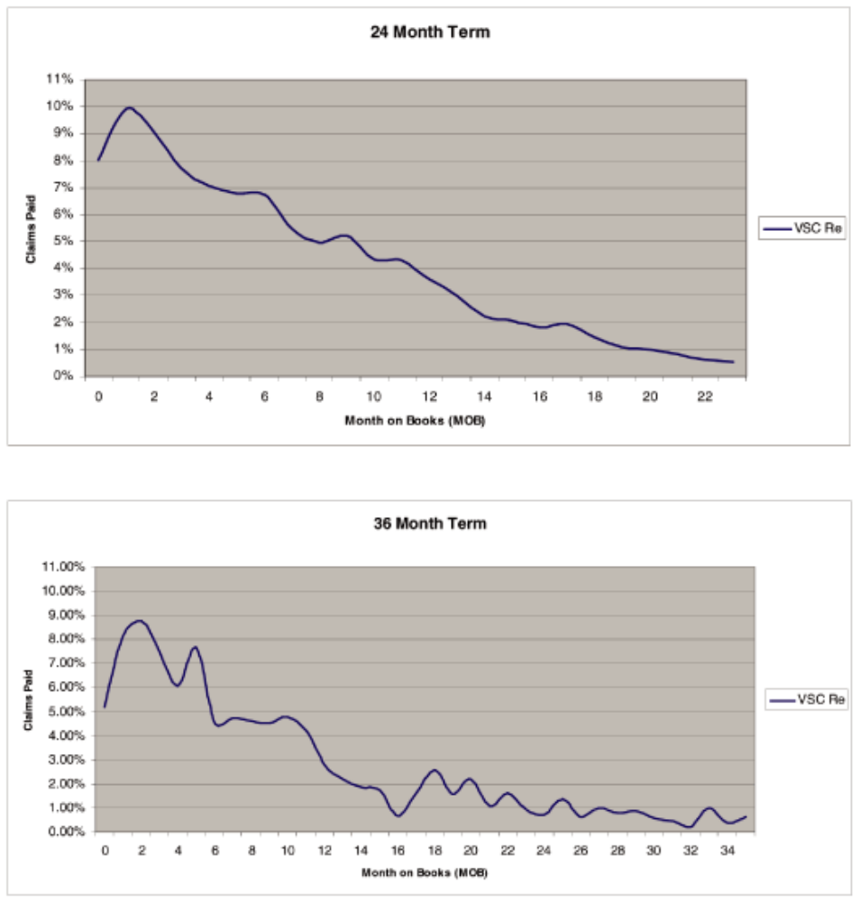

 |  | 24 Month Term – |  | 36 Month Term
Month on Book |  | % of Total Claims |  | – % of Total
Month on Book |  | Paid |  | Claims Paid
1 | 8% |  | 5%
2 | 10% |  | 8%
3 | 9% |  | 9%
4 | 8% |  | 7%
5 | 7% |  | 6%
6 | 7% |  | 8%
7 | 7% |  | 5%
8 | 5% |  | 5%
9 | 5% |  | 5%
10 | 5% |  | 5%
11 | 4% |  | 5%
12 | 4% |  | 4%
13 | 4% |  | 3%
14 | 3% |  | 2%
15 | 2% |  | 2%
16 | 2% |  | 2%
 | 3

 |  | 24 Month Term – |  | 36 Month Term
Month on Book |  | % of Total Claims |  | – % of Total
Month on Book |  | Paid |  | Claims Paid
17 | 2% |  | 1%
18 | 2% |  | 2%
19 | 1% |  | 3%
20 | 1% |  | 2%
21 | 1% |  | 2%
22 | 1% |  | 1%
23 | 1% |  | 2%
24 | 1% |  | 1%
25 |  |  | 1%
26 |  |  | 1%
27 |  |  | 1%
28 |  |  | 1%
29 |  |  | 1%
30 |  |  | 1%
31 |  |  | 1%
32 |  |  | 0%
33 |  |  | 0%
34 |  |  | 1%
35 |  |  | 0%
36 |  |  | 1%

Previously we had used the average of the pro-rata and Rule of 78 methods. Below are graphs and a table that compare our newly adopted methodology of recognizing revenue in proportion to our projected costs.
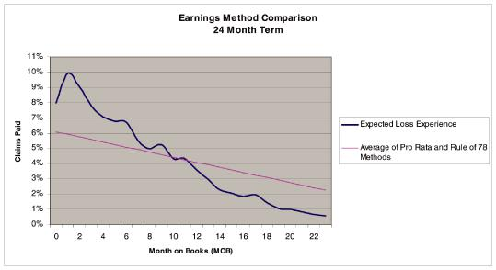

4

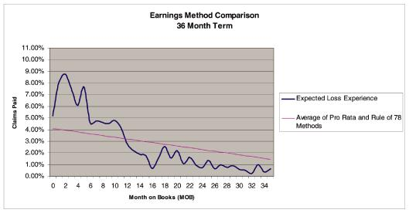

 |  |  | 24 Month Term |  |  |  |  | 36 Month Term
 |  | Expected Loss |  |  | Average of Pro |  | Expected Loss |  |  | Average of Pro
Month on Books |  | Expected Loss |  |  | Rata and Rule |  | Expected Loss |  |  | Rata and Rule
Month on Books |  | Experience |  |  | of 78 Methods |  | Experience |  |  | of 78 Methods
1 |  | 8% | 6% |  |  | 5% |  | 4%
2 |  | 10% | 6% |  |  | 8% |  | 4%
3 |  | 9% | 6% |  |  | 9% |  | 4%
4 |  | 8% | 6% |  |  | 7% |  | 4%
5 |  | 7% | 5% |  |  | 6% |  | 4%
6 |  | 7% | 5% |  |  | 8% |  | 4%
7 |  | 7% | 5% |  |  | 5% |  | 4%
8 |  | 5% | 5% |  |  | 5% |  | 4%
9 |  | 5% | 5% |  |  | 5% |  | 3%
10 |  | 5% | 5% |  |  | 5% |  | 3%
11 |  | 4% | 4% |  |  | 5% |  | 3%
12 |  | 4% | 4% |  |  | 4% |  | 3%
13 |  | 4% | 4% |  |  | 3% |  | 3%
14 |  | 3% | 4% |  |  | 2% |  | 3%
15 |  | 2% | 4% |  |  | 2% |  | 3%
16 |  | 2% | 4% |  |  | 2% |  | 3%
17 |  | 2% | 3% |  |  | 1% |  | 3%
18 |  | 2% | 3% |  |  | 2% |  | 3%
19 |  | 1% | 3% |  |  | 3% |  | 3%
20 |  | 1% | 3% |  |  | 2% |  | 3%
21 |  | 1% | 3% |  |  | 2% |  | 3%
22 |  | 1% | 3% |  |  | 1% |  | 3%
23 |  | 1% | 2% |  |  | 2% |  | 2%
24 |  | 1% | 2% |  |  | 1% |  | 2%
25 |  |  |  |  |  | 1% |  | 2%
26 |  |  |  |  |  | 1% |  | 2%
27 |  |  |  |  |  | 1% |  | 2%
28 |  |  |  |  |  | 1% |  | 2%
29 |  |  |  |  |  | 1% |  | 2%
30 |  |  |  |  |  | 1% |  | 2%
31 |  |  |  |  |  | 1% |  | 2%
 |  |  | 5

 |  |  | 24 Month Term |  |  |  |  | 36 Month Term
 |  | Expected Loss |  |  | Average of Pro |  | Expected Loss |  |  | Average of Pro
Month on Books |  | Expected Loss |  |  | Rata and Rule |  | Expected Loss |  |  | Rata and Rule
 |  | Experience |  |  | of 78 Methods |  | Experience |  |  | of 78 Methods
32 |  |  |  |  |  |  | 0% |  |  | 2%
33 |  |  |  |  |  | 0% |  | 2%
34 |  |  |  |  |  | 1% |  | 2%
35 |  |  |  |  |  | 0% |  | 2%
36 |  |  |  |  |  | 1% |  | 1%

We will continue to monitor how our contracts are performing by pool and adjust our revenue recognition methodology in the future if the projected pattern of costs changes for certain pools or in total.

- Tell us whether, as part of your change in recognition method, you stratified your pools into smaller or different subsets. If so, please explain the extent of such changes, the nature of this stratification, and the characteristics by which they were stratified.

We did not stratify our pools beyond original contract term as we are not aware of any other characteristics that we could use to stratify our population that would identify differing historical claims patterns. Our main retail price schedule differentiates based upon contract term as we believe contract term to be the main driver of risk. Both the nature of our business model and policy limitations in the vehicle service contracts cause the pool of vehicles covered by our vehicle service contract product to be much more similar than the overall population of vehicles. Our financings carry high interest rates, which exclude most consumers from entering into contracts for newer or expensive vehicles. Our policy limitations exclude a variety of vehicles such as, but not limited to, vehicles more than 13 years old, vehicles with more than 8 cylinders, commercial use vehicles, electric powered vehicles, and high performance vehicles.

For new vehicle service contracts written during the quarter ended December 31, 2009, the average covered vehicle was 7 years old and had 93,000 miles. For new vehicle service contracts written during this same time period, 76% of the covered vehicles were between 5 and 10 years old and 72% had between 60,000 and 119,999 miles.

We will continue to update our analysis of historical costs under the vehicle service contract program as appropriate, including the consideration of other characteristics that may have led to different patterns of cost incurrence, and revise our revenue recognition timing for any changes in the pattern of our expected costs as they are identified.

Acknowledgement:

In connection with the above responses, we acknowledge that:

- Credit Acceptance is responsible for the adequacy and accuracy of the disclosure in the filing;

- staff comments or changes to disclosure in response to staff comments do not foreclose the Commission from taking any action with respect to the filing; and

- Credit Acceptance may not assert staff comments as a defense in any proceeding initiated by the Commission or any person under the federal securities laws of the United States.

We believe the above responses have adequately addressed your comments. Please direct any additional questions regarding the review and this related response to me at (248) 353-2700 ext. 4575.

Sincerely,

/s/ Kenneth S. Booth

Kenneth S. Booth

Chief Financial Officer

Credit Acceptance Corporation

- Stephanie Hunsaker, Division of Corporate Finance, U.S. Securities and Exchange Commission Vince Tomkinson, Grant Thornton LLP

6

